7.1-1)
Since a heap is a complete binary tree, maximum elements are when all the leaves of height h are present , so total number of elements=2^{h+1} -1 . Minimum elements are when only one leaf of height h is present. So total number of elements = (2^{h} –1) + 1 = 2^{h} .

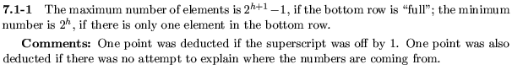

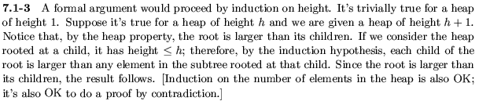

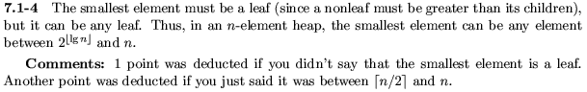

7.1-6)
23
17 14
6 13 10 1
5 7 12

This is not a heap (or max-heap) since the parent of element 7, which is element 6 is smaller than 7.

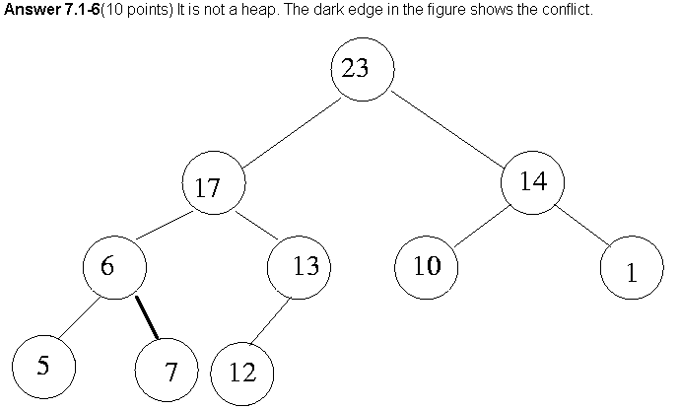

7.2-1)

27
17 3
16 13 10 1
5 7 12 4 8 9 0

→

27
17 10
16 13 3 1
5 7 12 4 8 9 0

→
27
17 10
16 13 9 1
5 7 12 4 8 3 0

7.2-5)
Consider a heap of n nodes where the root node has been changed to contain the smallest value of all the nodes. Now when we call heapify on the root, the value will have to be exchanged down with its child at every level, till it reaches the lowest level, this is because, after every swapping, the value will still be smaller than both its children(since it is the minimum), till it reaches the lowest level where it has no more children. So in such a heap, the number of exchanges to heapify the root will be equal to the height of the tree, which is (lg n). So the time complexity is = lg n in this case. So the worst case running time is Ω(lg n).

7.3-1)
A=(5,3,17,10,84,19,6,22,9)

5 5
3 17 3 i 17
i 10 84 19 6 → 22 84 19 6 →
22 9 10 9

5 i 5
i 3 19 84 19
22 84 17 6 → 22 3 17 6 →
10 9 10 9

84
22 19
10 3 17 6
5 9

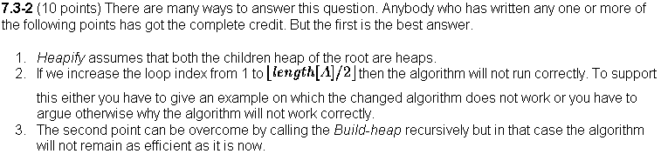

7.4-3)
Assume that in the heapsort algorithm, the build heap step produces a heap of size n which is
(n,n-1,…1). So in each of the n-1 heapify calls, the time taken for heapify is exactly equal to the height of the heap at each iteration, since at the beginning of each heapify iteration, the element at the root is the minimum element. So total time taken for all the heapify operations is lg n + lg(n-1) + lg(n-2) + …lg(1) = lg(n*(n-1)*(n-2)..2*1) = lg (n!) which is Ω(nlg n).

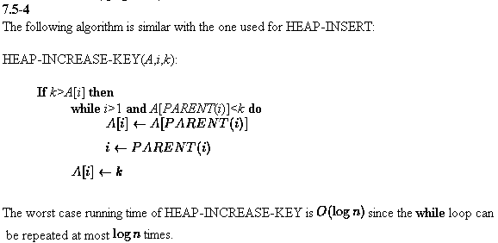

7.5-5)
An implementation of heap delete is
HEAP-DELETE(A,i)
{
exchange A[i] ←→ A[length(A)]
heap-size[A]=heap-size[A]-1
Heapify(A,i)
}
Basically it deletes the element at node i, and replaces it with the last element, and then does heapify from the node i. This will run in O(lg n) time.

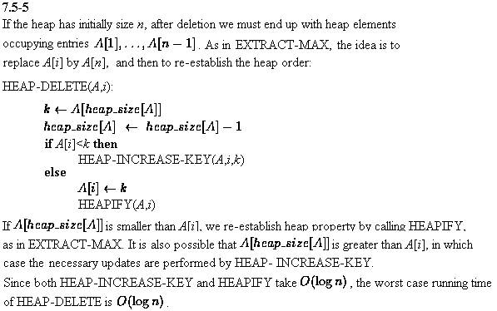

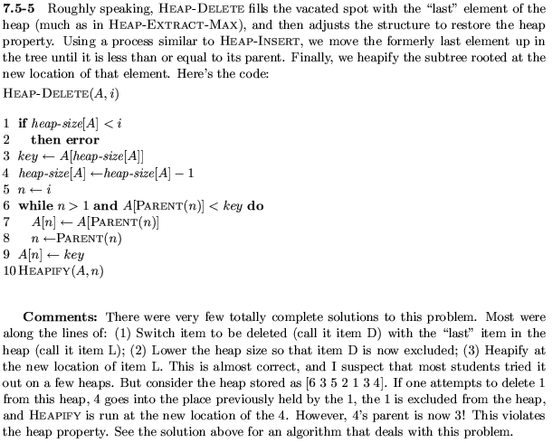

7.5-6)
Give an O(n lg k)-time algorithm to merge k sorted lists into one
sorted list, where n is the total number of elements in all the input
lists.
First, build a heap of k nodes, each of which is one of the k sorted
lists. The first element of each list is the node's key.
Next, systematically pop off one element at a time.

1 DoneList = null;
2 While root->SortedList is not null
3 x = Pop (root->SortedList)
4 enqueue (DoneList, x)
5 if root->SortedList is null
6 EXTRACT-MAX // delete the root and maintain heap property
7 else
8 HEAPIFY(root)
9 return DoneList

Complexity Analysis:
First, building a k-node heap takes O(k lg k)
Next, the while loop (line 2) iterates for n times because each
iteration pops one node and it ends when all nodes have been popped.
(line 2) loops n times
(line 3) Pop takes O(1).
(line 4) Enqueue takes O(1).
(line 5-6) if and EXTRACT-MAX takes O(lg k)
(line 7-8) HEAPIFY takes O(lg k)
The overall complexity is O(k lg k + n * lg k) = O(n lg k).

